Domain Controllers (DC) are what control Active Directory Services.

In DC is where all the information for the computer and user accounts are stored at.

In DC we can add user accounts and computer accounts. ( in the database for the DC).

Schema tells the DC, how it should save/store the information about the user and computers accounts.

Example: User: username, email, office, etcc (Data for the user accounts)

Computer : pc-name, ID, etc (Data for the computer accounts)

Schema is extendable, which means we can add more Information for the User or Computer accounts.

Security: Who has access to WHAT!

For security we can add Computer and User into Groups. Than we can assign different Groups, different resources/permissions in the network.

OU = Organization Units 🡺 Groups, but for administrative purposive. The global administrator can create an OU, which is composed of users. Than out of the users, it chooses 1, who will be the admin of that OU, that means he has Admin-Rights (which can be given or revoke from the global admin), and he can manage that OU. The OU-Admin rights, will be given from the global admin.

A Domain are all the Computer and Users, assigned to a Domain Controller.

Domain: google.com

Subdomain: Europe.google.com

Every subdomain has its own DC, its own user and computers, but it uses the Schema of the main Domain (google.com)

Two Way transitive trust, the domain and subdomain trust each other. (two way)

Transitive: Every subdomain trusts other subdomain.

So with Two way transitive trust, we can have for example a user in the domain, and we can move it to the subdomain, having the same password, emails, username etc (Information) but the Subdomain-Admin will give new rules/resources to the user that just got moved.

A tree, is when we add subdomain to the original domain.

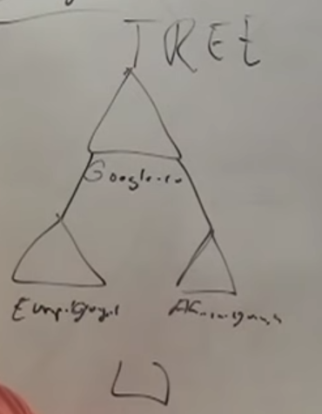

We can also make a one-way trust.

A Forest 🡺 connecting 2 different trees with trust.

<https://www.youtube.com/watch?v=hZ2QiiHyTnU>

Active Directory is:

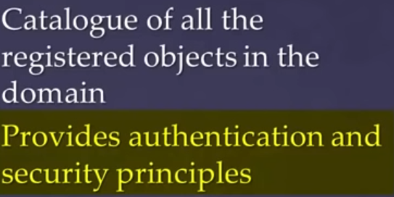

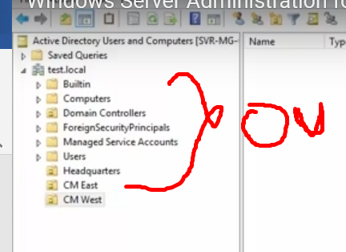

This are all OU ( Organizational Units)

Creating a new Group: Select an OU, right click 🡺 new Group

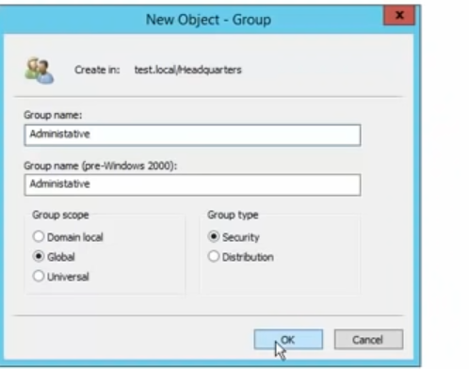

To check members of a group:

Right Click on the Group, Properties and than members

We can move users to differen OU/Groups. Right click and than:

Properties 🡺 Group 🡺 Remove from Group, move etc

We can also disable an account

We can coyp a user, with all its settings. Than we can make the same user, but with a different name, in the same OU, groups and settings

Important in the USER:

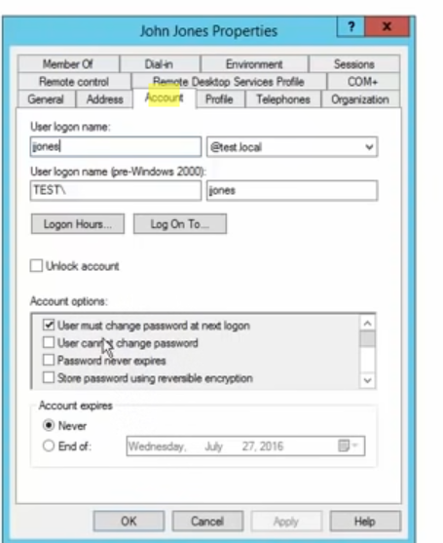

**Group policy**

When setting up a Group Policy, only the users and computers of that OU, will be affected!!

There is also a Default Domain policy, it is a global Policy, which apply to the entire Domain.

To edit it:

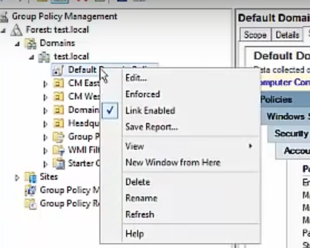

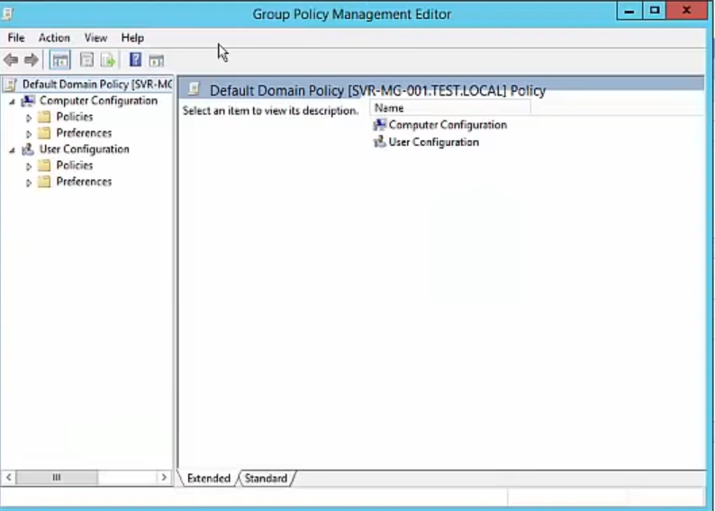

Navigating through the Group Policy Management Editor:

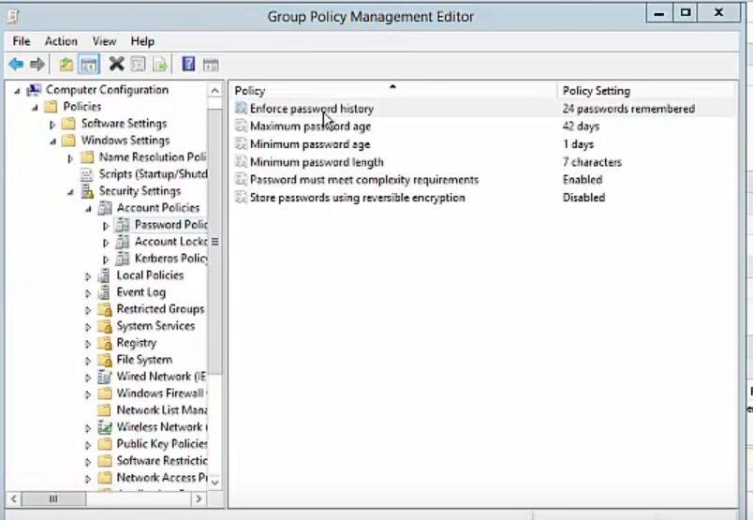

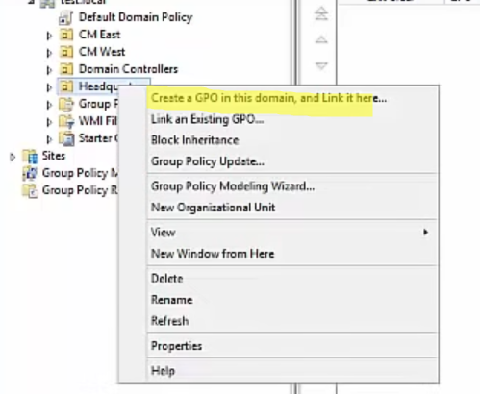

GPO= Group Policy Object

To apply a certain GPO to a Single OU/Group/Users/Computers etc :

Into scope

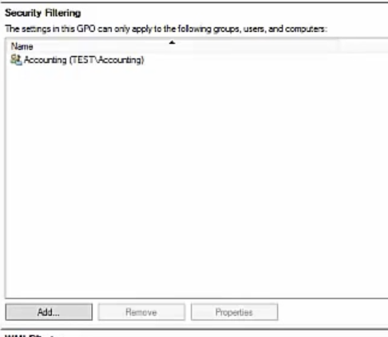

We can add a Print Server, as a role.

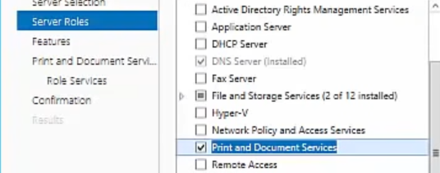

Than Windows Server 🡺 Tools🡺 Print Management.

We can install Printers, Network Printers.

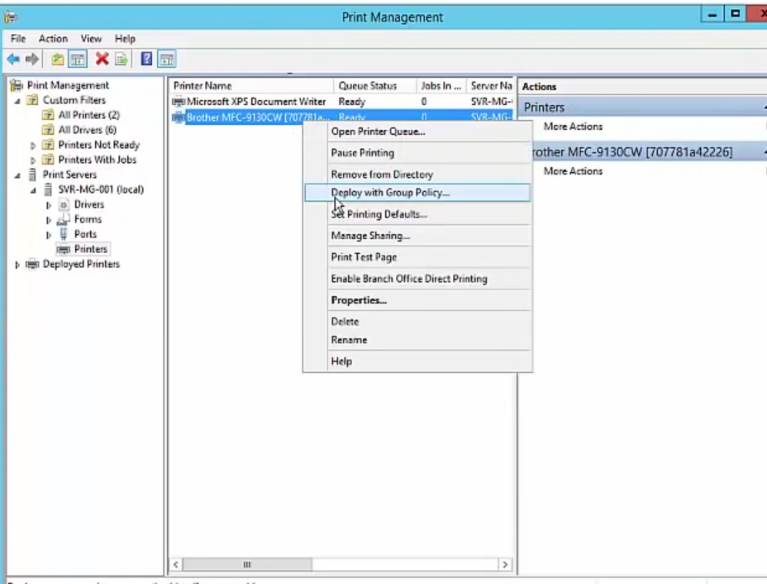

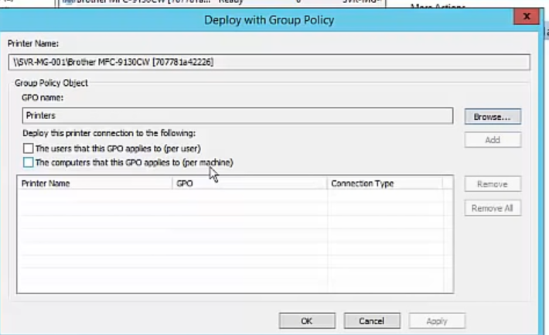

**File Sharing**

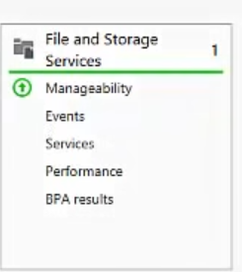

**New Course:**

Domain: Is a collection of Objects -> groups, user accounts, computers.

Domain Controller : server with Active Directory installed

Tree: A collection of Domains. We have a Parent Domain, and a child Domain. RTS.local und china.RTS.local

Forest: Collection of trees with all the shared resources within those domains.

Global Catalog: A Global Catalog server is a domain controller that stores copies of **all Active Directory objects in the forest.** Thus, the Global Catalog allows users and applications to find objects in any domain of the current forest by searching for attributes included to GC. A typical domain controller stores a complete replica of objects in its own domain, but not for other domains in the forest.

DNS – Resolve a name to IP Address

Step to do before installing Active Directory:

Rename the Windows Server!

Static IP Address and Preferred DNS!!’

Install Active Directory:

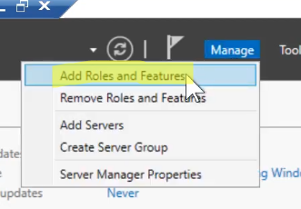

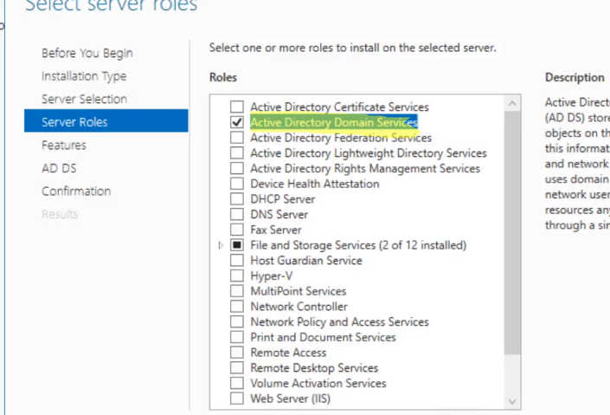

The other steps are all generic ( einfach next)

After installing: 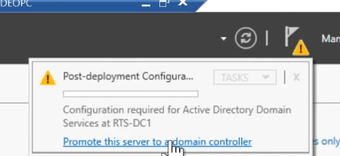

Than we need to choose between 3 different deployment configuration techniques:

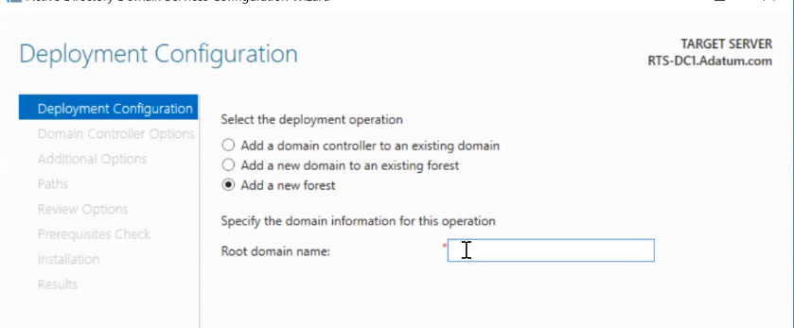

**Add a domain controller to an existing domain**: when we have already a configured DC, but we make another one in case of Single Point of Failure (Redudant)

**Add a new domain to an existing forest**: In case we want to open a new branch (for example branch in UK, our Standartort is in Deutschland).

**Add a new Forest**: When this is the first Domain Controller for our company (used to do testing or starting a domain from the scratch)

As the root domain**: DomainName**.local

**In Domain Controller Options**: We are have checked Domain Name SystemServer, bcs in this lab this is the default DC. Also, the DSRM in case we need to restore the domain

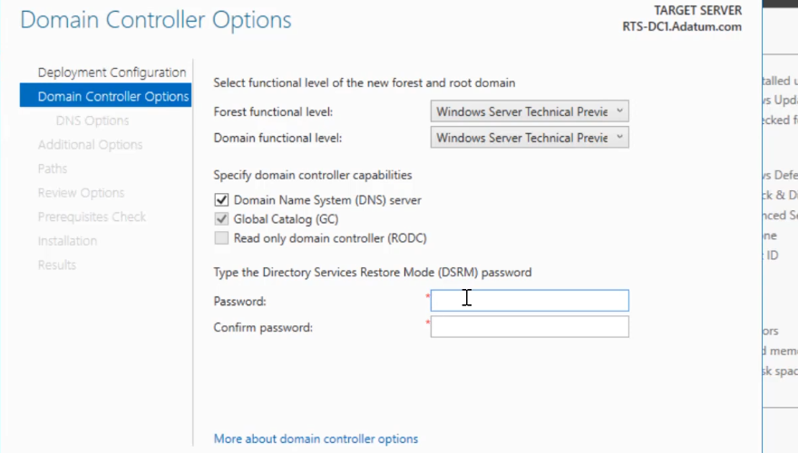

In Windows Server: Manage 🡺 Active Directory User and Computers.

This are the default Containers:

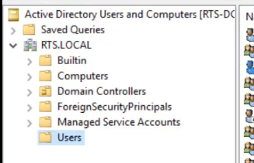

In the user container we can add a new user

Under Manage 🡺 Group Policy Management.

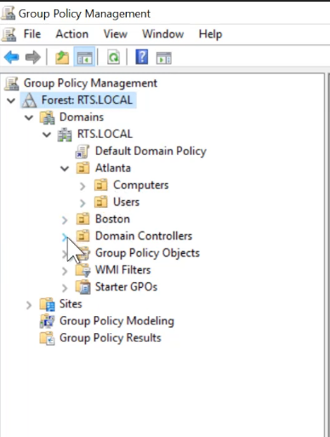

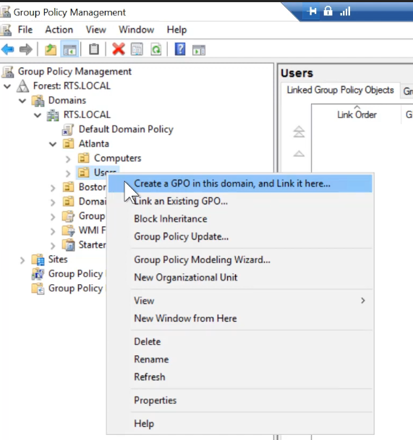

Ndts.dit 🡺 is where all the infor about OU,User and PC are stored up there.

To watch: <https://www.youtube.com/watch?v=1JpOEdNnILQ>

Jobskillshare, login and watch AD User Managment